Containers in OGSA
***need to update to the OGF doc template***

Status of This Memo
This document is in draft stage and should be considered as in flux. Distribution is unlimited.

Copyright Notice
Copyright © Global Grid Forum (2006). All Rights Reserved.

Abstract
This memo provides information to the Grid community on the information modeling of containers for OGSA (Open Grid Services Architecture). It defines the proposed container object for inclusion in DMTF’s Common Information Model. Specific containers, such as the OGSA Basic Execution Services container, should be defined as profiles and/or extension elements of container. Distribution is unlimited.

Contents

1. Overview 3
2. The Container Model 3
3. UML 4
4. Discussion of the Model Elements 6
4.1 New Classes 6
4.2 New Associations 7
4.3 Properties Added to Existing Classes 7
4.4 Methods Added to Existing Classes 7
5. Managed Object Format (MOF) 7
6. XML (WS-CIM) 10
7. Security Considerations 10
8. Glossary 10
9. Author Information 10
10. Acknowledgements 10
11. References 10
12. Full Copyright and Intellectual Property Notices 11

Overview
The Container Model describes the managed objects and their relationships for defining the execution environment for activities in a grid. The CIMv2.14 final schema is the foundation for the development of this model. It is expected that this model will be folded into CIMv2.15 preliminary.
In this document we provide the container model in UML, DMTF CIM Managed Object Format (MOF). DMTF provides their XML representation via automatic conversion tool (MOF to CIM-XML, via CIM DTD).
The keywords “MUST”, “MUST NOT”, “REQUIRED”, “SHALL”, “SHALL NOT”, “SHOULD”, “SHOULD NOT”, “RECOMMENDED” and “MAY” used in this document are to be interpreted as described in [RFC2119].

The Container Model
OGSA defines a container as a collection of running entities and activities, e.g. services, jobs. A container may, for example, be a queuing service, a Unix host, a J2EE environment, or a collection of containers (a façade or a virtual organization of job containers). A container has resource properties that describe both static and dynamic information, e.g. OS version, types of executables allowed, policies, security, load, QoS information. A container may implement some subset of the manageability interfaces such as Web Services Distributed Management (WSDM) or WS-Management. The container has various relationships to other resources. The container uses various services such as reservation services, logging services, information services, job management services, and provisioning services.
A single new class, Container, is defined as a subclass of the Collection class. This class captures the basic semantics of containers. It may be necessary to subclass this Container class to express all the semantics of a specific container. For example, OGSA needs a Basic Execution Services (BES) container. BES defines operations that are specific to its container, and therefore to capture all the BES semantics, BES may subclass the Container class.
The Container acts as an aggregator of the managed properties necessary for the use of the container through its various relationships with the ManagedElement class. This means that a very large number of attributes may be associated with a container. For ease of implementation, usability, extensibility, and interoperability, the details of what is contained in the container should be defined by a profile. The BES container aggregates and exposes attributes needed to make scheduling decisions. Although there are few attributes of a container, for extensibility it is easier to define a profile for implementation.
The class added to CIMv2.15 experimental in support of the Container work is marked as ‘Experimental’ in the CIM MOF and as {E} in the UML diagram and appears in bold font for easier identification.
The model elements are discussed in a bit more detail in Section 4 following the presentation of the UML in Section 3. The Managed Object Format (MOF) description is given in Section 5. (MOF is a textual rendering of UML, defined in the CIM Specification [CIMspec] published by the DMTF). Section 6 offers a corresponding XML description using WS-CIM Mapping Specification [WSCIMmap].
Note: It is expected that additional CIM classes, attributes, and methods may be defined and need to be added to CIM as the specific container profile work progresses. These will be documented in similar fashion to the Container class in a separate informational document.

UML
The figure below depicts the classes and properties of the container model. The new class with its attributes and methods are highlighted in red bold.
Question: Do we need an attribute to denote the environment of container, such as whether the container is a queuing service, a J2EE hosting environment, a host (operating system based), etc?
Observation: The current version of the BES spec defines 2 attributes: common name and long name. We do not have to define these in the container model because the container class inherits caption and description, respectively, from the ManagedElement class.
Question: Are there any other elements of BES that we think are of a general nature and should be added to this Container class definition?
Question: In thinking about how info model and service relate, perhaps we should consider defining a BES Service (sub-classed from CIM_Service) where the BES Service contains the remaining BES container specific factory operations? Reference new visio drawing.

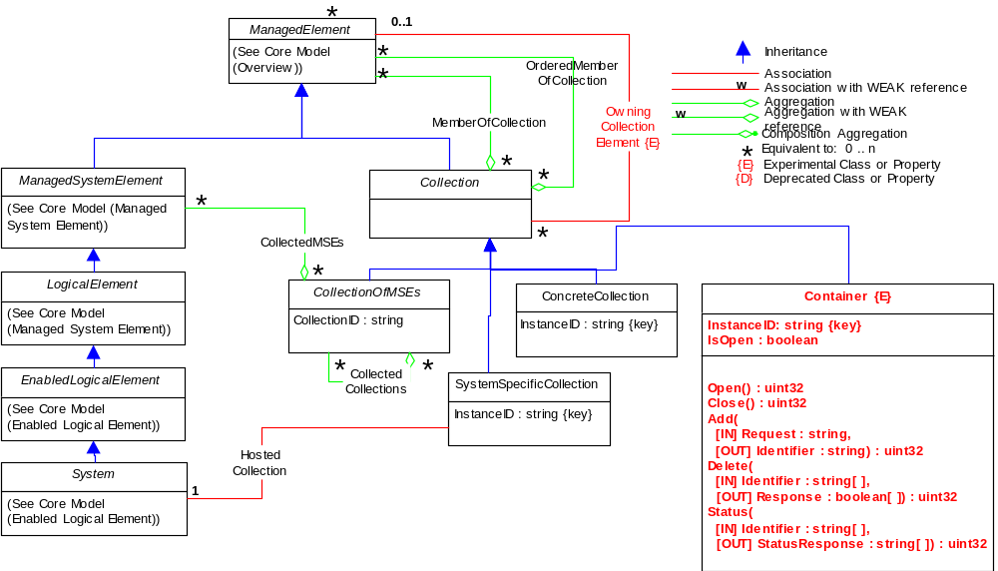
Figure 1: Original Container Model

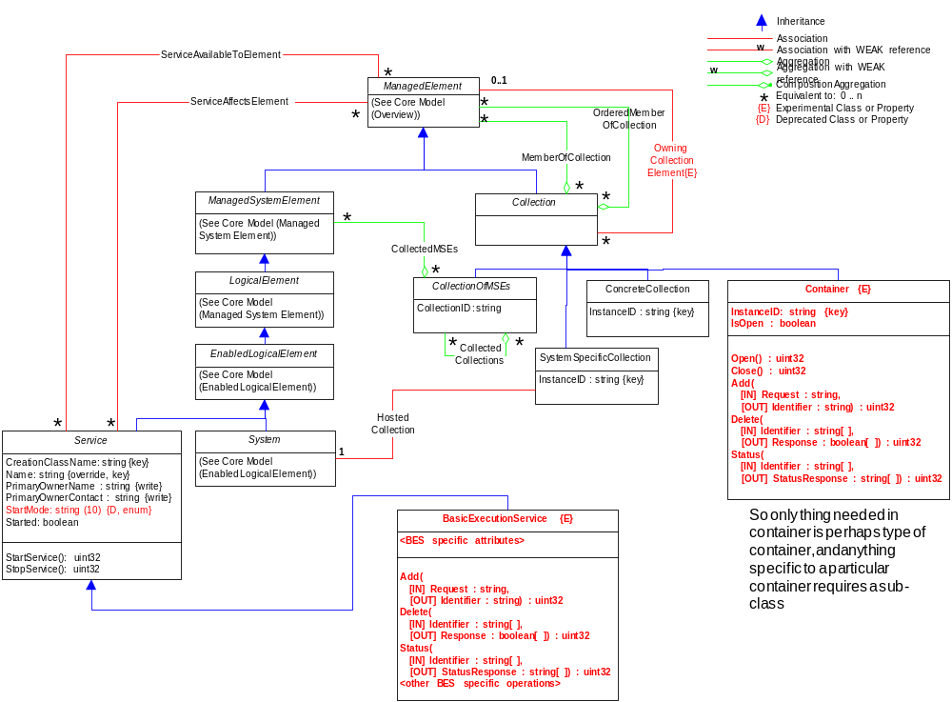
Figure 2. Revised Model

Discussion of the Model Elements
This section describes the classes, associations, properties, and methods proposed to be added to CIM v2.15 experimental in support of a container model.

New Classes

Container
The Container class inherits from the CIM_Collection class. It is a concrete class meaning that it is instantiable without further subclassing (although it certainly may be subclassed). It is a collection of running entities and activities, e.g. services, jobs. A container may, for example, be a queuing service, a Unix host, a J2EE environment, or a collection of containers (a façade or a virtual organization of job containers). A container has resource properties that describe both static and dynamic information, e.g. OS version, types of executables allowed, policies, security, load, QoS information. A container may implement some subset of manageability interfaces such as Web Services Distributed Management (WSDM) or WS-Management. The container has various relationships to other resources. The container uses various services such as reservation services, logging services, information services, job management services, and provisioning services. Because this container class serves as an aggregator of other classes (attributes and methods) and can aggregate any ManagedElement (all classes in CIM are ManagedElements), the contents of a specific container are best described by a profile.
Contents:
- InstanceID (required)
Within the scope of the instantiating Namespace, InstanceID opaquely and uniquely identifies an instance of this class.
- IsOpen
A boolean attribute that defines the current ability of the container as available, e.g. to accept new activities.
- Open
This operation moves the container into a state where it is open for requests. For example, within the context of the OGSA Basic Execution Services specification, this means the container can start accepting new activities, and the operation maps to ‘StartAcceptingNewActivities()’ interface.
- Close
This operation moves the container into a state where it is closed to requests. For example, within the context of the OGSA Basic Execution Services specification, this means the container stops accepting new activities, and the operation maps to ‘StopAcceptingNewActivities()’ interface.
- Add
This operation adds requests to the container. For example, within the context of the OGSA Basic Execution Services specification, this means that a new activity is added to the container, and the operation maps to the ‘CreateActivity()’ interface.
- Delete
This operation requests that one or more items in the container be terminated. For example, within the context of the OGSA Basic Execution Services specification, this means that a new or existing activity in the container can be requested to be terminated, and the operation maps to the ‘TerminateActivities()’ interface.
- Status
This operation requests the status of one or more items in the container. For example, within the context of the OGSA Basic Execution Services specification, this means that the status of one or more activities within the container can be obtained, and the operation maps to the ‘GetActivityStatuses()’ interface.

New Associations
None.

Properties Added to Existing Classes
None.

Methods Added to Existing Classes
None.

Managed Object Format (MOF)
The schema is described in Managed Object Format, defined in [CIMspec].
The MOF below reflects the UML diagram in this document. It is included to provide the details and descriptions necessary to understand the UML.
Question: open() and close() as detailed below have no inputs, but do have a return code. BES analogous operations have no inputs and no outputs. How do we want to define open and close?

// ==================================================================
// CIM_Container
// ==================================================================
[Experimental, Version ( "2.15.0" ), Description (
"A concrete version of Collection. This class represents a "
"collection of running entities and activities, e.g. services, "
"jobs. A Container may, for example, be a queuing service, "
"a Unix host, a J2EE environment, or a collection of "
"containers (a facade or a virtual organization of job "
"containers). A Container has properties that describe both "
"static and dynamic information, e.g. OS version, types of "
"executables allowed, policies, security, load, QoS "
"information. A Container may implement some subset of "
"manageability interfaces. The Container uses various services "
"such as reservation services, logging services, information "
"services, job management services, and provisioning services. "
"The Container acts as an aggregator if the managed properties "
"necesary for the use of the container through its various "
"relationships with the ManagedElement class. Specific "
"containers necessary for implementation and interoperability "
"should, in general, be defined by a profile instead of "
"subclassing. ")]
class CIM_Container : CIM_Collection {

[Key, Description (
"Within the scope of the instantiating Namespace, InstanceID "
"opaquely and uniquely identifies an instance of this class. "
"To ensure uniqueness within the NameSpace, the value of "
"InstanceID should be constructed using the following "
"'preferred' algorithm: \n"
"<OrgID>:<LocalID> \n"
"Where <OrgID> and <LocalID> are separated by a colon ':', "
"and where <OrgID> must include a unique name. It can be a "
"copyrighted, trademarked, or otherwise unique name that is "
"owned by the business entity that is creating or defining "
"the InstanceID. Or, it could be a registered ID that is "
"assigned to the business entity by a recognized global "
"authority. (This requirement is similar to the <Schema "
"Name>_<Class Name> structure of Schema class names.) In "
"addition, to ensure uniqueness <OrgID> must not contain a "
"colon (':'). When using this algorithm, the first colon to "
"appear in InstanceID must appear between <OrgID> and "
"<LocalID>. \n"
"\n"
"<LocalID> is chosen by the business entity and should not "
"be re-used to identify different underlying (real-world) "
"elements. If the above 'preferred' algorithm is not used, "
"the defining entity must ensure that the resulting "
"InstanceID is not re-used as any of the InstanceIDs "
"produced by this or other providers for the NameSpace of "
"this instance.")]
string InstanceID;

[Description (
"A boolean property that defines the current ability of "
"container as available (when set to the value of 1), e.g. "
"to accept new activities.")]
boolean IsOpen;

[Description (
"This operation moves the container into a state where it is "
"open for requests. For example, within the context of the "
"OGSA Basic Execution Services, this means the container can "
"start accepting new activities, and the operation maps to "
"the StartAcceptingNewActivities() interface. The return "
"value should be 0 if the request was successfully executed, "
"1 if the request is not supported, and some other value if "
"an error occurred.")]
uint32 Open();

[Description (
"This operation moves the container into a state where it is "
"closed to requests. For example, within the context of the "
"OGSA Basic Execution Services, this means the container "
"stops accepting new activities, and the operation maps to "
"the StopAcceptingNewActivities() interface. The return "
"value should be 0 if the request was successfully executed, "
"1 if the request is not supported, and some other value if "
"an error occurred. It is up to the implementation or "
"subclass of Container to establish dependencies between "
"the Open and Close methods, and for example, to provide "
"more sophisticated capabilities such as scheduled close, "
"etc. In a subclass, the set of possible return codes could "
"be specified, using a ValueMap qualifier on the method. "
"The strings to which the ValueMap contents are 'translated' "
"may also be specified in the subclass as a Values array "
"qualifier.")]
uint32 Close();

[Description (
"This operation add requests to the container. For example, "
"within the context of the OGSA Basic Execution Services, "
"this means that a new activity is added to the container, "
"and the operation maps to the CreateActivity() interface. "
"The return value should be 0 if the request was "
"successfully executed, 1 if the request is not supported, "
"and some other value if an error occurred.")]
uint32 Add(

[IN, Description (
"Describes a single request that is to be executed by the
"container.")]
string Request,

[OUT, Description (
"Identifier associated with the requested execution.")]
string Identifier);

[Description (
"This operation requests that one or more items in the
"container be terminated. For example, within the context "
"of the OGSA Basic Execution Services, this means that a new "
"or existing activity in the container can be requested to "
"be terminated, and the operation maps to the "
"TerminateActivities() interface. The return value should "
"be 0 if the request was successfully executed, 1 if the "
"request is not supported, and some other value if an error "
"occurred.")]
uint32 Delete(

[IN, Description (
"Identifies one or more items in the container that are "
"to be terminated.")]
string Request[],

[OUT, Description (
"Boolean response value for each requested termination. "
"A value of 1 (true) indicates successful termination.")]
boolean Response[]);

[Description (
"This operation requests the status of one or more items in "
"the container. For example, within the context "
"of the OGSA Basic Execution Services, this means that the "
"status of one or more activities within the container can "
"be obtained, and the operation maps to the
"GetActivityStatuses() interface. The return value should "
"be 0 if the request was successfully executed, 1 if the "
"request is not supported, and some other value if an error "
"occurred.")]
uint32 Status(

[IN, Description (
"Identifies one or more items in the container whose "
"status will be obtained be terminated.")]
string Identifier[],

[OUT, Description (
"A response for each requested termination. ")]
string StatusResponse[]);

);

};

XML (WS-CIM)
An XML representation of Container using the WS-CIM Mapping Specification, defined in [WSCIMmap], will be included in the next version of this document.
Question: WS-CIM appears not to be the right XML representation to list here from an OGSA point of view. From a DMTF/CIM point of view, WS-CIM can be algorithmically generated (per DSP0230). For this information document, I recommend that we do not include the WS-CIM XML representation. Instead our time is better spent getting our XML representation of advertised resources correct. Thoughts?

Security Considerations
This specification defines the model and XML Schema for containers. While the interactions of containers with its activities must be secured, the security details are outside the scope of this specification. Instead, it is assumed that security is addressed in specifications that define how this model and XML Schema are bound to specific communication protocols (such as [CIMOPS] or [OGSA]) and programming environments.

Glossary
<any terms we should list?>

Author Information
Ellen Stokes
IBM Corporation
11400 Burnet Rd
Austin, TX 78758
+1 512 838 0552
stokese@us.ibm.com

Acknowledgements
We are grateful to numerous colleagues for discussions on the topics covered in this document, in particular (in alphabetical order, with apologies to anybody we've missed): <list the names>.

References
[RFC2119] Bradner, Scott, "Key Words for use in RFCs to Indicate Requirement Levels", RFC 2119, http://www.ietf.org/rfc/rfc2119.txt
[CIM2.14final] DMTF CIM Schema, Version 2.14 Final, http://www.dmtf.org/standards/cim_schema_v214.php
[CIM2.15prelim] DMTF CIM Schema, Version 2.15 Experimental, http://www.dmtf.org/standards/cim_schema_v215.php
[CIMspec] DMTF, CIM Specification V2.2, http://www.dmtf.org/standards/documents/CIM/DSP0004.pdf
[CIMXML] DMTF, Representation of CIM in XML, http://www.dmtf.org/standards/documents/CIM/DSP0201.pdf
[WSCIMmap] DMTF, WS-CIM Mapping Specification, http://www.dmtf.org/standards/published_documents/DSP0230.pdf
[BES] OGF, OGSA Basic Execution Service Specification, http://www.ogf.org/XXX.pdf (to be updated when spec is final)

Full Copyright and Intellectual Property Notices
Full Copyright Notice
Copyright © Global Grid Forum (2006). All Rights Reserved.
This document and translations of it may be copied and furnished to others, and derivative works that comment on or otherwise explain it or assist in its implementation may be prepared, copied, published and distributed, in whole or in part, without restriction of any kind, provided that the above copyright notice and this paragraph are included on all such copies and derivative works. However, this document itself may not be modified in any way, such as by removing the copyright notice or references to the GGF or other organizations, except as needed for the purpose of developing Grid Recommendations in which case the procedures for copyrights defined in the GGF Document process must be followed, or as required to translate it into languages other than English.
The limited permissions granted above are perpetual and will not be revoked by the GGF or its successors or assigns.
This document and the information contained herein is provided on an "AS IS" basis and THE GLOBAL GRID FORUM DISCLAIMS ALL WARRANTIES, EXPRESS OR IMPLIED, INCLUDING BUT NOT LIMITED TO ANY WARRANTY THAT THE USE OF THE INFORMATION HEREIN WILL NOT INFRINGE ANY RIGHTS OR ANY IMPLIED WARRANTIES OF MERCHANTABILITY OR FITNESS FOR A PARTICULAR PURPOSE."

Intellectual Property Statement
The GGF takes no position regarding the validity or scope of any intellectual property or other rights that might be claimed to pertain to the implementation or use of the technology described in this document or the extent to which any license under such rights might or might not be available; neither does it represent that it has made any effort to identify any such rights. Copies of claims of rights made available for publication and any assurances of licenses to be made available, or the result of an attempt made to obtain a general license or permission for the use of such proprietary rights by implementers or users of this specification can be obtained from the GGF Secretariat.
The GGF invites any interested party to bring to its attention any copyrights, patents or patent applications, or other proprietary rights which may cover technology that may be required to practice this recommendation. Please address the information to the GGF Executive Director.

Or in the future, management interfaces from the convergence of the WSDM and WS-MAN specifications.
This class is planned to be submitted to DMTF for inclusion in CIMv2.15 experimental.
Or in the future, management interfaces from the convergence of the WSDM and WS-MAN specifications.

